**DAILY ONLINE ACTIVITIES SUMMARY**

|  |  |  |  |  |  |  |  |
| --- | --- | --- | --- | --- | --- | --- | --- |
| **Date:** | **08/06/2020** | | | | **Name:** | **Sheetal** | |
| **Sem & Sec** | **8 B** | | | | **USN:** | **4AL16CS091** | |
| **Online Test Summary** | | | | | | | |
| **Subject** | | **SMS** | | | | | |
| **Max. Marks** | | **60** | | **Score** | | **60** | |
| **Certification Course Summary(Internship)** | | | | | | | |
| **Task** | **Creating BI custom Layout file using Template** | | | | | | |
| **Company** | | | **Gain-Insights** | **Duration** | | | **8 hr** |
| **Coding Challenges** | | | | | | | |
| **Problem Statement:**  **1) generate all unique partition of integer** | | | | | | | |
| **Status:completed** | | | | | | | |
| **Uploaded the report in Github** | | | | **Yes** | | | |
| **If yes Repository name** | | | | [alvas-education-foundation](https://github.com/alvas-education-foundation)/ **[sheetal-shettigar](https://github.com/alvas-education-foundation/sheetal-shettigar)** | | | |
| **Uploaded the report in slack** | | | | **Yes** | | | |

ONLINE TEST

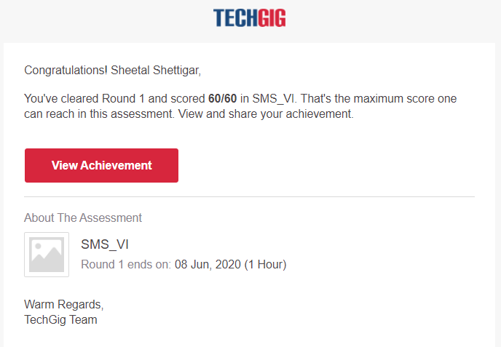

CODING CHALLENGE:

PROGRAM 1 :

def printArray(p, n):

for i in range(0, n):

print(p[i], end = " ")

print()

def printAllUniqueParts(n):

p = [0] * n # An array to store a partition

k = 0 # Index of last element in a partition

p[k] = n # Initialize first partition

# as number itself

while True:

printArray(p, k + 1)

rem_val = 0

while k >= 0 and p[k] == 1:

rem_val += p[k]

k -= 1

if k < 0:

print()

return

p[k] -= 1

rem_val += 1

while rem_val > p[k]:

p[k + 1] = p[k]

rem_val = rem_val - p[k]

k += 1

p[k + 1] = rem_val

k += 1

print('All Unique Partitions of 2')

printAllUniqueParts(2)

print('All Unique Partitions of 3')

printAllUniqueParts(3)

print('All Unique Partitions of 4')

printAllUniqueParts(4)

|  |
| --- |
|  |